REFERENCE LINK HERE:

[**Requirement**](https://canvas.cityu.edu.hk/courses/34829/files/folder/package/Coursework?preview=6218731)[**Github**](http://github.com/122project/122project.github.io)

[**Site**](http://122project.github.io) **Task:**

Problem Specification and Design **20%**

Python Implementation **40%**

Program correctness **20%**

User and technical documentation **5%**

One-page reflection (per person) **5%**

Presentations and Demonstration Video **10%**

**Allocation:**

**Zac** Present & Demo Vid + Python

**Rex** Python Implementation  
**Amy** Summary of work done+User & technical documentation + Program correctness(test data)+Input data  
**Justine** Problem Spec & Design+Powerpoint

Member Names and ID: Chan Yik Kit (56237852)

Chen Tak Hei (56226087)

Lai Justine (56235545)

Zachary Law Hong Chun (56237888)

**Module: 122COM Introduction To Algorithms**

**Group Project Assignment**

**Group members:**

**Law Hong Chun Zachary**

**Chen Tak Hei Rex**

**Chan Yik Kit Amy**

**Lai Justine**

| **Coventry University/CityU**  Submit to Canvas | | | |  |
| --- | --- | --- | --- | --- |
| **Group Number: Group 2**  **StudentID and Names:**  Chan Yik Kit (56237852)  Chen Tak Hei (56226087)  Lai Justine (56235545)  Zachary Law Hong Chun (56237888)  **Declaration:** I / We declare that this Coursework is my / our own work. Cheating is a serious academic offence. I / We have read and agree to abide by the University guidance on Academic Honesty.  **Signature(s):**  **Time taken to complete assignment (hrs):** | | | |  |
| **Module Code/Title:** CHK122COM Introduction to Algorithms    **Lecturer/Tutor:** Terence Chan  **Hand-out Date:** Week 1  **Assignment No./Title**: Coursework  **Assignment Type**: Group and Individual    **Estimated Time (hrs): 50 hours** | **Due Date:** Week 12 | | |  |
| **Learning Outcomes Assessed (or on separate sheet)**  Intended Module Learning Outcomes 1,2,3,4 | | | |  |
| **Assessment Criteria (on separate sheet)**  (According to the coursework document) | | | **Max** | **Awarded** |
|  |  |
| **Comments**    **Assessor"s signature:** **Date:** | | **Total**    **Final Mark** |  |  |
|  |  |
|  |

Problem Specification and Design

This program is for the online IZZ bookstore. Due to Covid-19, the willingness of citizens to hang out has dramatically decreased. People would like to stay at home more. Therefore, we would like to build a website for IZZ bookstore to let people shop while they are staying at home. The input requirement is shown below:

Register (form):

Enter name/password/email/phone no./address/gender/date of birth

Name: no symbol, must fill in with characters from A to Z (must fill in this info)

If input name with symbol ➡ shows "your name should not include symbol"

Password: must include letters and numbers, no symbol (must fill in this info)

If password format incorrect (no letters or numbers)

➡ shows "password must include at least one letter and number"

(password inputs include symbol)

➡ shows "password cannot include symbol"

Valid email: (must fill in this info)

If email do not exist ➡ shows "invalid email"

Address: correct format (must fill in this info)

If address incorrect ➡ shows "invalid address"

Gender:

List:

Male

Female

N/A

Phone no.: string(8)

If phone no. longer or shorter than 8 ➡ shows "invalid phone number"

If input all valid data ➡ send confirmation code to user phone to activate account

If user blank some info that must be filled in ➡ shows "please fill in all information needed"

Date of birth: (optional)

Drop down lists for year, month, and day

Login:

Enter Valid name/valid password

If data input valid ➡ login to the homepage of web

If data input invalid ➡ show "invalid password or username"

Forgot password button:

If clicked ➡ pop out a window and ask user to enter their email or phone number in order to send the verification code to them to login

Search engine:

Search different books by title, author, publisher, publish year

If enter wrong information ➡ shows "no result found"

If enter key words ➡ shows all results that have the key word

Home page:

The home page will show recommendations of some of the selected books. When the user clicks on the picture of the book, it will show the general information such as author, publisher and price of the book on the left-hand side at the website. Users can choose to add to the shopping cart or just close the window and search for another book.

Class diagram:

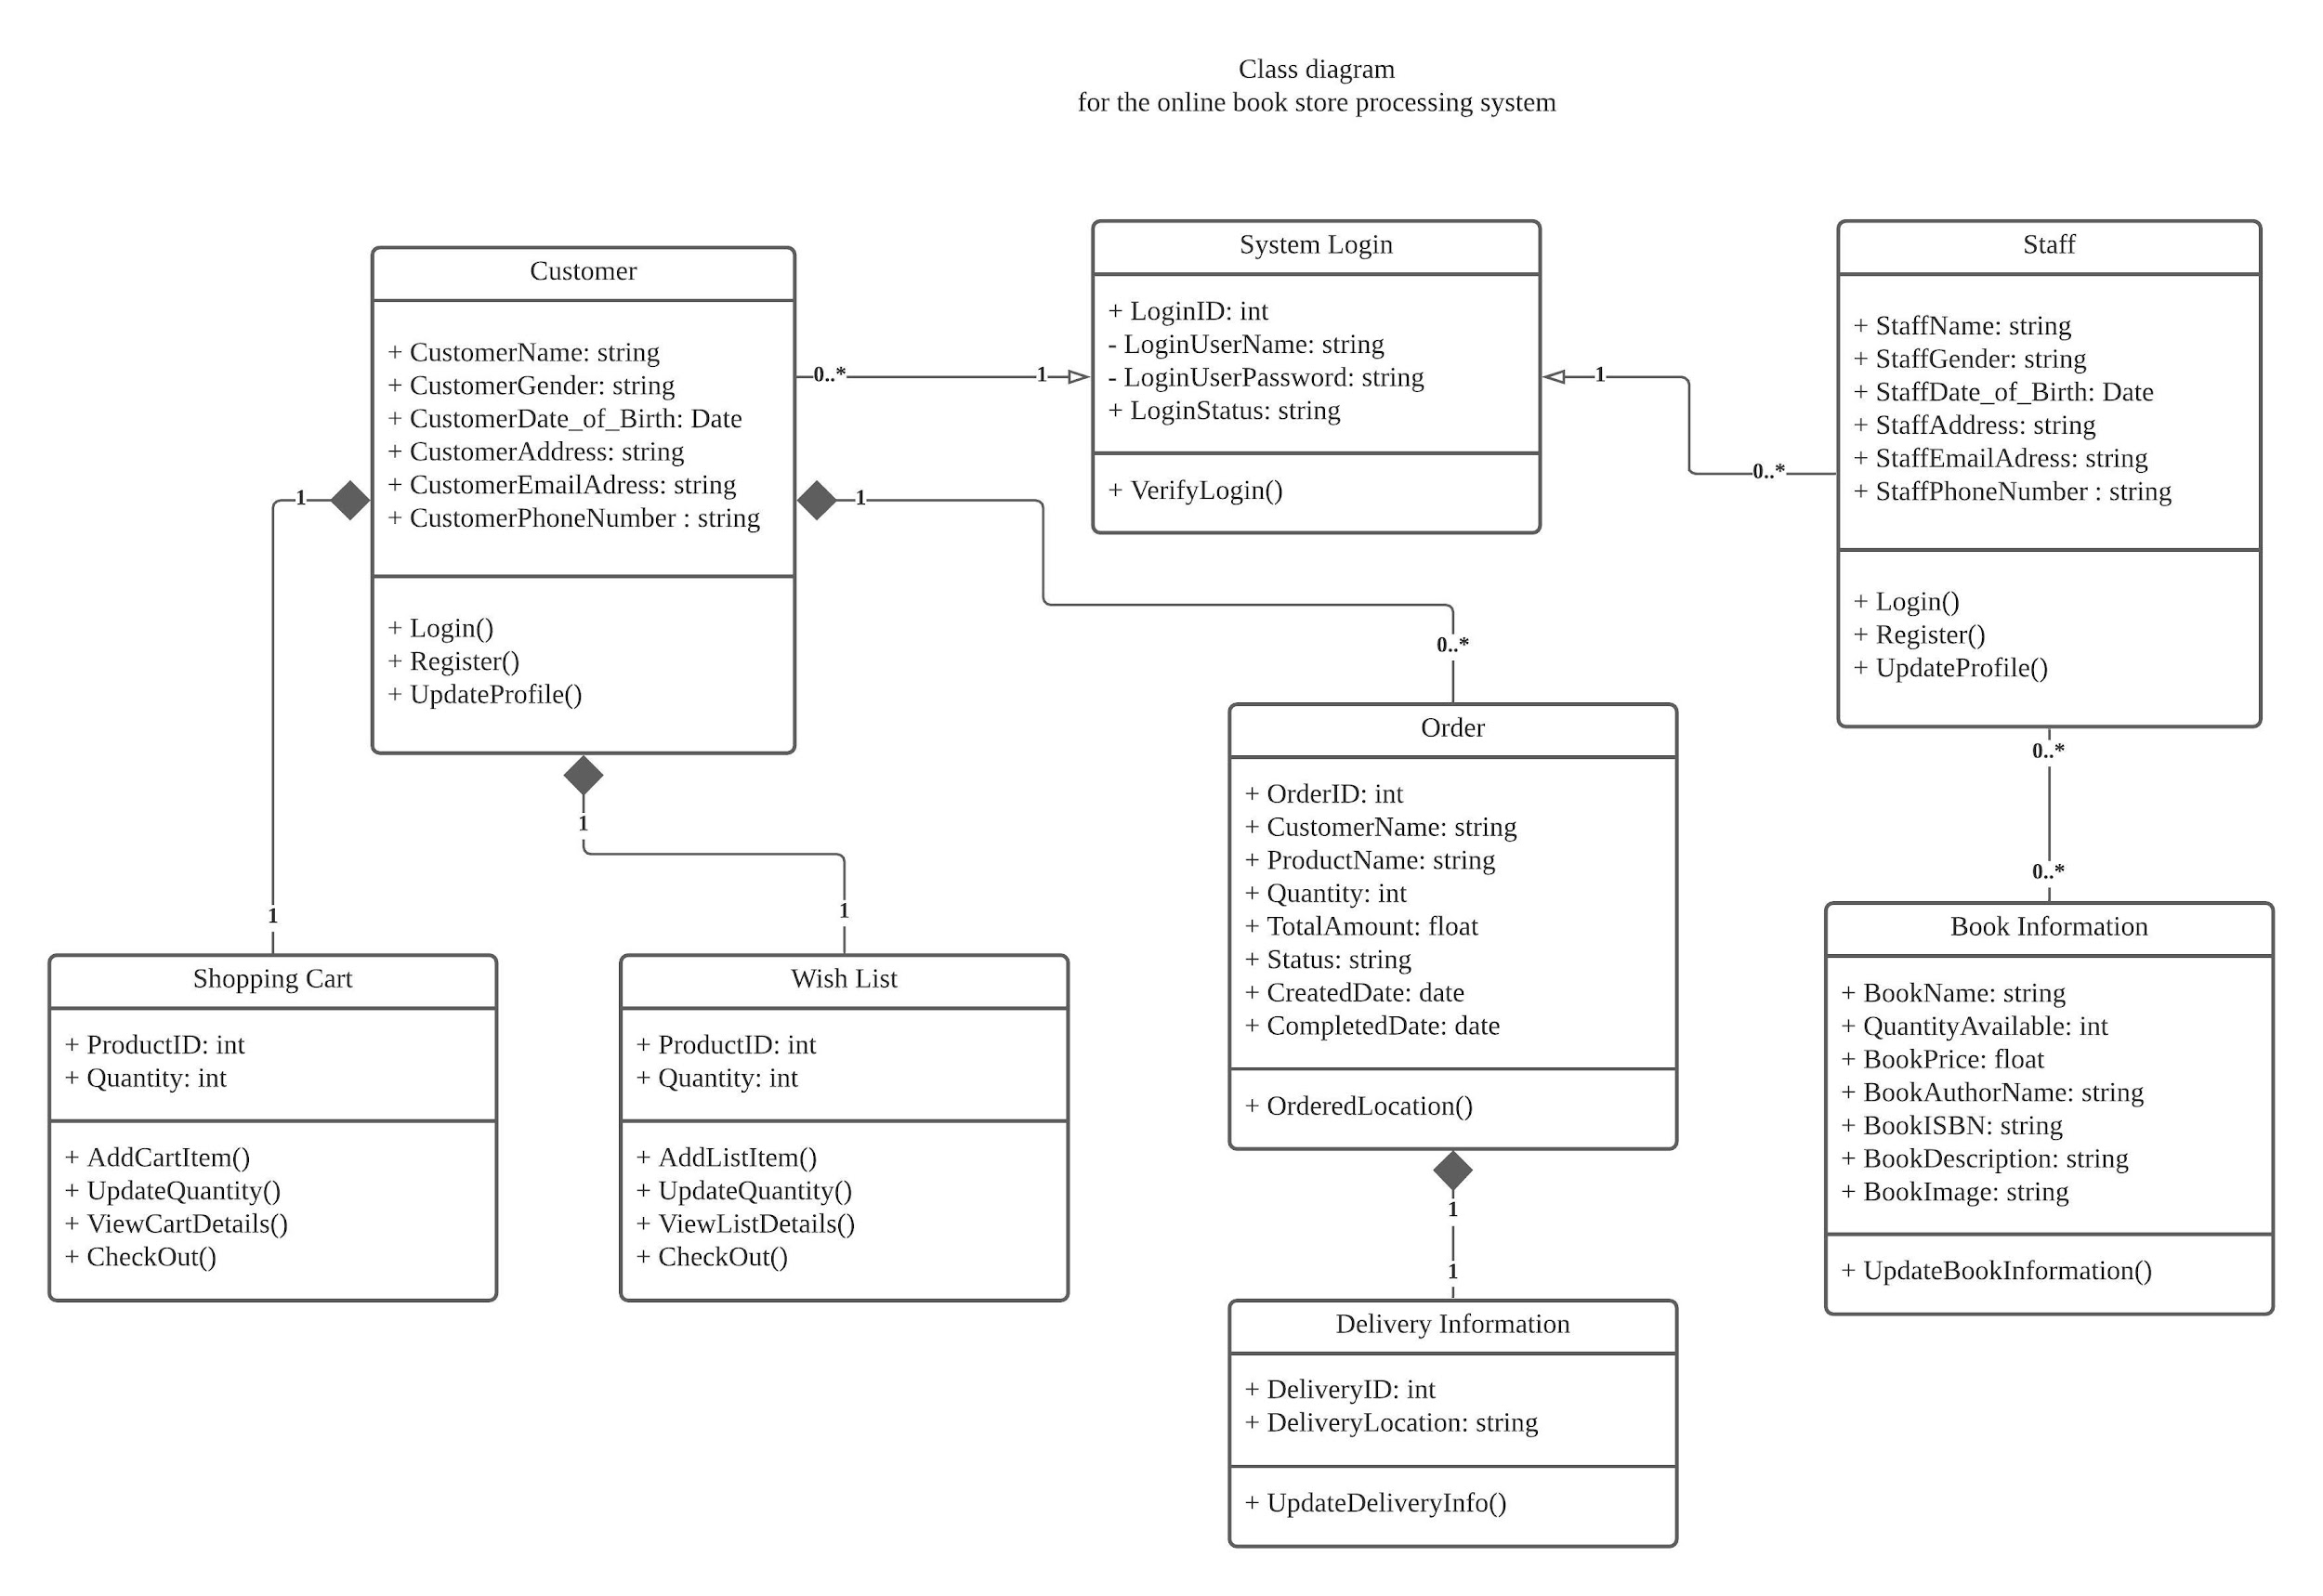

**Summary of work done dated as at 13th November**

After brainstorming and discussing with all members of our group, we all agreed and decided to create an online bookstore processing system - IZZ Bookstore.

This is our logo - IZZ Bookstore.

First of all, let"s have a brief introduction to our website. There is a database created for supporting the data which our website needs. The website system allows customers to **search** and **shop** after a **registered account**. A **login function** will be provided for those potential customers for more efficient **payment** and information recording.

The above program specification and design show that customers should first **input some personal information**, including at least **name, password, email for payment confirmation for payment, and address for delivery**. Besides, customers can use the **searching function** to find their wanted books. We will let the website run for around-the-clock. The customer reference information, including the **ISBN, book titles, authors, the database publisher**, is also given when the customer clicks on certain books.

So far we have finished developing the layout and working style of our online bookstore processing system. Below are the functions/buttons/data that are given on our website:

* Pages of account create interface
* Log-in^
* Home interface with Logo^
* Numbers^ of books choice with related informations
* Wish List^
* Add to shopping cart button and its linking^
* Shopping Cart^
* check out^

^means that still need to fix or not yet finish

Last but not least, what we"re going to do next is complete the web and python software coding design, review the database, and deal with those errors. We are going to have more buttons for website configurations, such as wish lists and more payment types. We would provide more book options, customer service support, and even upload more data such as user guides to be more user-friendly and improve the user interface for having a consummate online bookstore processing system.

Fin.

**Inputted book information examples 14 books**

**(picture, ISBN, title, author, date, publisher, description, price)**

，["9789620757396","社會契約論 The Social Contract","讓-雅克．盧梭(Jean-Jacques Rousseau)","-","商務印書館(香港)有限公司","縱觀歷史，有些書能改變世界，這些著作扭轉了我們對自身和他人的看法，甚至引發爭論、產生異見，挑起戰爭，催化革命。這些著作發人深省，激發憤懣，鼓動情緒，提供慰藉。它們使我們的生命變得豐盛，卻同時帶來破壞。“偉大思想系列”叢書精挑細選了偉大思想家、先驅、激進分子和夢想家的經典著作，當中的思想曾經撼動世界，也塑造了讀者的人生。盧梭對於人類自由讓人震撼的呼聲推動了法國大革命，而且至今仍主導著我們對如何作出管治的討論。《社會契約論》被視為一份政治恐慌的藍圖，也作為民主的基礎宣言。","92"]

<https://www.cp1897.com.hk/bookinfo/image/450/9789620757396z.jpg>

, ["9780571356508", "Find Me", "Andre Aciman", "-", "Faber & Faber", "Elio believes he has left behind his first love - but as an affair with an older man intensifies, his thoughts turn to the past and to Oliver. Oliver, a college professor, husband and father, is preparing to leave New York. The imminent trip stirs up longing and regret, awakening an old desire and propelling him towards a decision that could change everything. In Call Me By Your Name, we fell in love with Oliver and Elio. Find Me returns to these unforgettable characters, exploring how love can ripple out from the past and into the future.", "126"]

<https://www.cp1897.com.hk/bookinfo/image/450/9780571356508z.jpg>

, ["9780241437414", "Art: A Visual History", "Robert Cumming", "-", "DK", "Discover the history of Western art - from prehistory to the 21st century - through profiles of over 650 artists and their key works. Covering every era and over 650 artists, this comprehensive, illustrated guide offers an accessible yet expansive view of art history, featuring everything from iconic works and lesser-known gems to techniques and themes. Offering a comprehensive overview of Western artists, themes, paintings, techniques, and stories, Art: A Visual History is packed full of large, full-colour images of iconic works and lesser-known gems. Covering every era, from 30,000BCE to the present, it includes features on the major schools and movements, as well as close-up critical appraisals of 22 masterpieces - from Botticelli"s Primavera to J. M. W. Turner"s The Fighting Temeraire. With detailed referencing, crisp reproductions and a fresh design, Art: A Visual History is a must-have for anyone with an interest in art history - from first-time gallery goers to knowledgeable art enthusiasts. What makes great art? Discover the answer now! Art: A Visual History is a must-have for anyone interested in the subject.", "280"]

<https://www.cp1897.com.hk/bookinfo/image/450/9780241437414z.jpg>

, ["9780141990903", "The Second Mountain", "David Brooks", "-", "Penguin", "DEBUTED AT NO.1 ON THE NEW YORK TIMES BESTSELLER LIST. NO.1 BESTSELLING AUTHOR OF THE SOCIAL ANIMAL. Are you on your first or second mountain? Is life about you - or others? About success - or something deeper? The world tells us that we should pursue our self-interest: career wins, high status, nice things. These are the goals of our first mountain. But at some point in our lives we might find that we"re not interested in what other people tell us to want. We want the things that are truly worth wanting.", "154"]

<https://www.cp1897.com.hk/bookinfo/image/450/9780141990903z.jpg>

, ["9789888528424", "EVERYDAY MASCULINITIES IN 21ST-CENTURY CHINA", "Magdalena Wong", "-", " Hong Kong University Press", "Everyday Masculinities in 21st-Century China: The Making of Able-Responsible Men argues that a moral dimension in Chinese masculinity is of growing significance in fast-changing China. "Able-responsible men"—those who can create wealth and shoulder responsibilities—have replaced the "moneyed elite" of the earlier reform-and-opening-up era as the dominant male ideal. With vivid and highly readable case studies, Wong presents a compelling account of the forces that coerce men to live up to the able-responsible standard. She demonstrates the impact this pressure has on the lives of not only boys and men, but also on women, and shows how it invites both complicit and resistant reactions. The book lays bare the socio-political context that nurtures the cultural expressions of hegemonic masculinity under the rule of Xi Jinping. The president himself has emerged in public consciousness as the embodiment of the ideal able-responsible man. Based on anthropological fieldwork in Nanchong, Sichuan, the book provides new perspectives on many topical issues that China faces. These include urbanization, labour migration, the one-child policy, love and marriage, gender and intergenerational dynamics, hierarchical male relationships, and the rise of mass displays of nationalism..", "400"]

<https://www.cp1897.com.hk/bookinfo/image/450/9789888528424z.jpg>

, ["9781524855048", "Cat"s Cafe: A Comics Collection", "Matt Tarpley", "-", "Andrew McMeel Publishing", "Welcome to Cat"s Cafe, a neighborhood coffee shop where all are welcome! Based on the popular webcomic, Cat"s Cafe introduces readers to the adorable denizens of this world. There"s Penguin, who has a bit of a coffee problem; Rabbit, whose anxiety sometimes overwhelms him; Axolotl, whose confidence inspires his friends; the always-supportive Cat, who provides hot drinks made with love and a supportive ear for anyone"s troubles; and many, many more. With a sensitive take on real issues and a gentle, positive outlook, Cat"s Cafe is about the power of acceptance, friendship, and love ... and delicious cups of coffee.", "142"]

<https://www.cp1897.com.hk/bookinfo/image/450/9781524855048z.jpg>

, ["9781780721989", "Fast Exercise", "Michael Mosley", "-", "Short Books", "In Fast Exercise, Michael Mosley, a self-confessed sloth, teams up with super-fit health journalist Peta Bee to dispel common exercise myths. They offer practical advice and a range of workouts that take just a few minutes a day and can be done any time, anywhere. Fast Exercise is for everyone: those who don"t enjoy exercise but want to lose fat and stay healthy, those who love exercise and want to enhance their performance, and those who just want to understand the science behind it all.", "128"]

<https://www.cp1897.com.hk/bookinfo/image/450/9781780721989z.jpg>

, ["9789570855319", "瓜地馬拉手繪旅行", "張佩瑜", "2019", "聯經出版事業股份有限公司", "本書特色：

＊收錄Peiyu佩瑜的素描和彩色寫生作品、當地生活的食衣住行、背包客須知、口袋訊息

＊地理老師Peiyu也常常現身解說氣候、地景、古蹟、語言等等的小道理

＊詳載Peiyu佩瑜有史以來最認真的西班牙文學習記，以及差點喪命於山地黑森林的超驚險迷途實況。", "163"]

<https://imgs.niusnews.com/upload/imgs/default/2020JULY_SHARON/quatemala/guatemala12.jpg>

, ["9789620447297", "路向 (增訂版)", "伍成邦, 陳曉蕾, 蘇美智", "2019", "三聯書店(香港)有限公司", "社會上有一群人，他們因為不同原因導致四肢傷殘，經歷過人生低谷，但最終都站起來，靠的不是雙腳，而是身下的輪椅、身邊人的支持，以及心態上的轉變。四位資深記者訪問了十二位路向四肢傷殘人士協會的會員，將他們曲折的人生旅途和心路歷程記錄下來，寫成《路向》一書，希望加深大眾對四肢傷殘人士的了解，亦透過他們的故事獲得啟發與鼓勵。", "138"]

<https://www.cp1897.com.hk/bookinfo/image/450/9789620447297z.jpg>

, ["9789620432170", "有米", "陳曉蕾", "2012", "三聯書店(香港)有限公司", "「『搵食』不是向人低頭，而是向土地彎腰；『為啖飯』付出的，不盡是妥協，而是有尊嚴地腳踏實地。這幾年到處採訪，深覺香港遠比我們想像的『富裕』。」繼《香港正菜》後，陳曉蕾繼續關心本港鄉郊生活。這次從香港的氣候入手，思考為何香港沒有了春天，而沒有春天對我們的生活有何影響。曉蕾也將視點對焦選擇「另類生活」的人，有搬到新界居住的年輕人，有知足變通的獨居老伯，有自耕自足的農耕人，有崇尚環保生活的情侶，看看這些在香港「核心價值」以外的香港人如何在這裡生活。", "108"]

<https://www.cp1897.com.hk/bookinfo/image/450/9789620432170z.jpg>

, ["9789578567580", "回到古代去旅行－－逛名城、訪美景，跟各朝大咖聊八卦", "解愛芹", "2020", "如果出版社", "從春秋戰國到清朝，本書提供歷朝歷代 ● 各朝大勢摘要 ● 重要歷史事件 ● 當代民風民情 ● 實用生活指南 讓你無論到哪個朝代，都知道要去哪些城市逛街？該拜訪哪位大人物？應該瞧瞧什麼重大事件才不枉此行？必備行李？違禁品有哪些？要攜帶哪種貨幣？有什麼值得購買的特產？該遵守什麼習俗？不一樣的旅行，帶你認識不一樣的中國歷史！", "120"]

<http://2-floor.dyndns.org/cover/9789578567580.jpg>

, ["9789620746017", "尋覓張愛玲", "吳邦謀", "2020", "商務印書館(香港)有限公司", "祖師奶奶張愛玲百歲誕辰紀念之作 香港收藏家吳邦謀為了紀念張愛玲百年誕辰及逝世廿五週年，特意蒐集超過二百件有關張愛玲的珍貴藏品，包括早期著作初版、報刊雜誌原刊小說、電影宣傳刊物、廣告及照片等，向讀者展示張愛玲顛簸跌宕的一生，她矢志不移的文學創作路，及她與香港交織的一點緣。書內部分藏品屬首次曝光，包括收錄張愛玲十一歲作品〈不幸的她〉的海外孤本《鳳藻》；附張愛玲鈐印的首作《傳奇》；張愛玲代表香港於《西風》雜誌徵文比賽獲獎的〈天才夢〉；電影《不了情》試映戲票等。每件藏品背後，記下張愛玲生命中或大或小的步伐，都是真實的見證，跟其著作同樣歷久彌新。著名畫家李志清更首度呈獻多幅畫風各異的手繪作品，描繪他眼中形象多變的張愛玲。", "148"]

<https://www.cp1897.com.hk/bookinfo/image/450/9789620746017z.jpg>

, ["9789863447818", "擺脫內耗人生－－走出焦慮、自責、憤怒、悔恨⋯⋯透過有效練習轉化情緒，讓你停止內在糾結、化解自我衝突，重新拿回生命主控權！", "于德志", "2020", "麥田出版股份有限公司", "你是感受的主人，而非感受的奴隸！要想結束這一切糟糕的心情，先停止與自己較勁！這本書裡，透過眾多心理學研究，從注意轉換、思維處理、感受管理、身體調整、表達傾聽等多個方向，解決我們持續內耗的心理困境，讓全新的思維與行為模式變成下意識的習慣，每個人都將擁有重新掌控人生的能力。", "148"]

<https://image6.thenewslens.com/2020/6/84s8i389mjzodya2q2kellrypc0alv.jpeg?auto=compress&q=80&w=1080>

, ["9781984820198", "Devolution", "Max Brooks", "2020", "Del Rey", "The #1 bestselling author of World War Z takes on the Bigfoot legend with a tale that blurs the lines between human and beast--and asks what we are capable of in the face of the unimaginable. As the ash and chaos from Mount Rainier"s eruption swirled and finally settled, the story of the Greenloop massacre has passed unnoticed, unexamined . . . until now. But the journals of resident Kate Holland, recovered from the town"s bloody wreckage, capture a tale too harrowing--and too earth-shattering in its implications--to be forgotten. In these pages, Max Brooks brings Kate"s extraordinary account to light for the first time, faithfully reproducing her words alongside his own extensive investigations into the massacre and the legendary beasts behind it. Kate"s is a tale of unexpected strength and resilience, of humanity"s defiance in the face of a terrible predator"s gaze, and inevitably, of savagery and death. Yet it is also far more than that. Because if what Kate Holland saw in those days is real, then we must accept the impossible. We must accept that the creature known as Bigfoot walks among us--and that it is a beast of terrible strength and ferocity. Part survival narrative, part bloody horror tale, part scientific journey into the boundaries between truth and fiction, this is a Bigfoot story as only Max Brooks could chronicle it--and like none you"ve ever read before.", "157"]

<https://www.cp1897.com.hk/bookinfo/image/450/9781984820198z.jpg>

**Test Cases**

1. **Customer register the account.**

Here is the screenshot of a user registering an account. First of all, he/she should click the human icon to go to the account creation page. And then follow instructions to insert that necessary personal information, including email **(in devote format with “@” and domain)**, password and confirm **(input the password again)**, gender (optional), birthday, and address for delivery.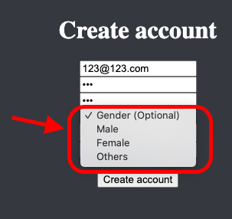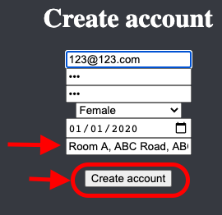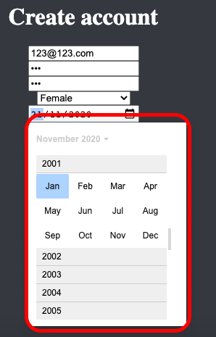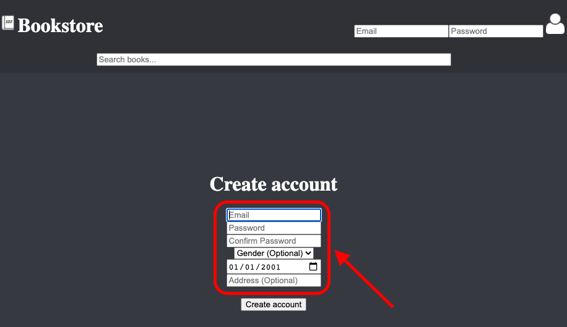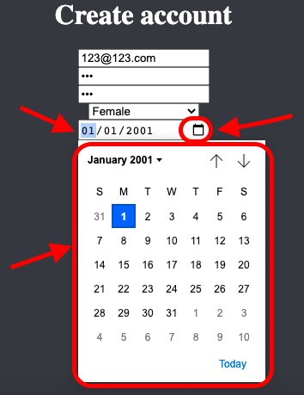

Here you can see that there is a drop-down list function for gender and a drop-down calendar for customers to choose the exact date. Three choices in the drop-down list can choose Male, female, and others. The calendar is divided by yearly and monthly to make it friendly. Lastly, the account created, the data is recorded in the database while customers can start using our website after login.

Here is one of the examples of the account info created.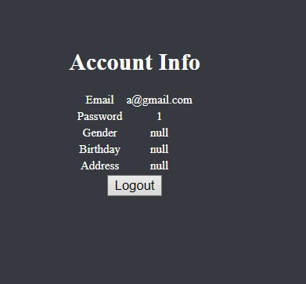

1. **Customer log-in**

Here is the login function. After creating the account, users should first input their email and password to login. Auto login after registered account.

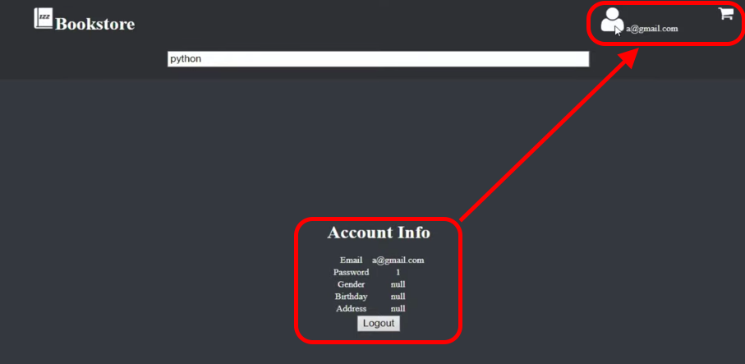

1. **Insert and search book informations**

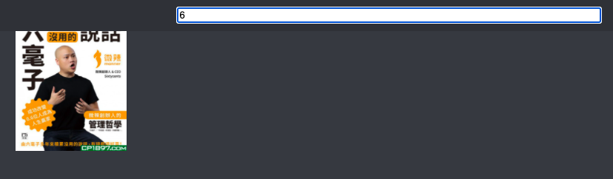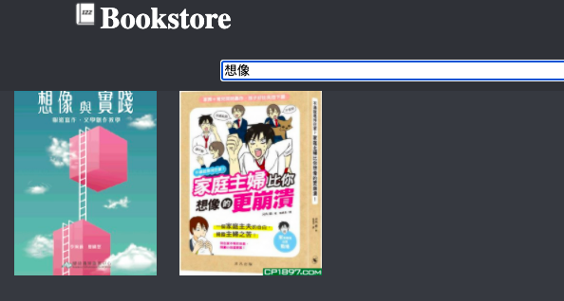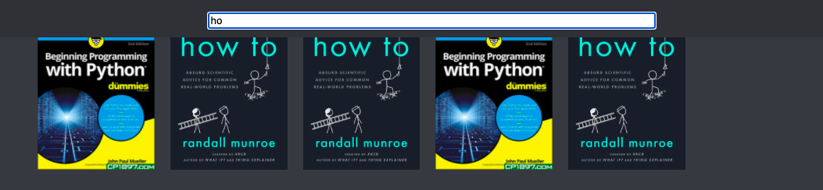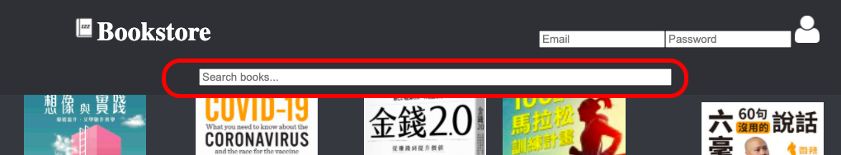

By searching the book title, author, publisher, and related book details in Chinese, English, and even number. The result will show when the user texts the information in the search box. The above are some examples.

1. **Showing the Book Information in the sidebar window**

Here is the output and screenshot of book details showing in the slide bar when the user clicks on the book icon.

1. **Log out**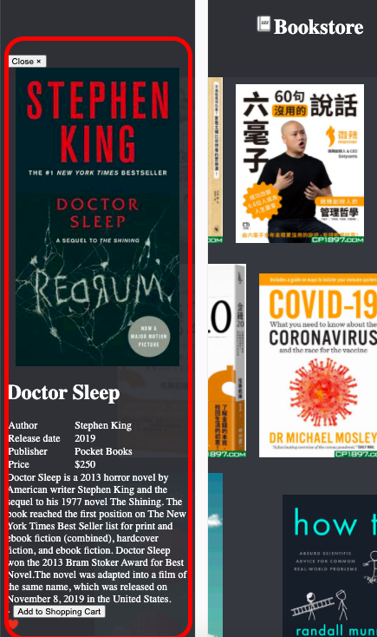

Here is the logout function. When a customer clicks on the Logout button, the system will let the user leave the page.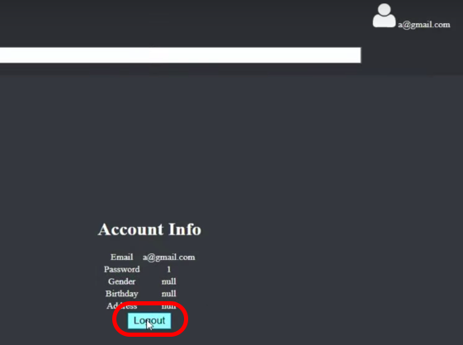

1. **Shopping Cart**

The above shows the shopping cart function and check out button. When customers click on the “Add to Shopping Cart” of books they are interested in, the system will automatically add it to the shopping cart and process the check out payment after the user clicks on the “Check out” button.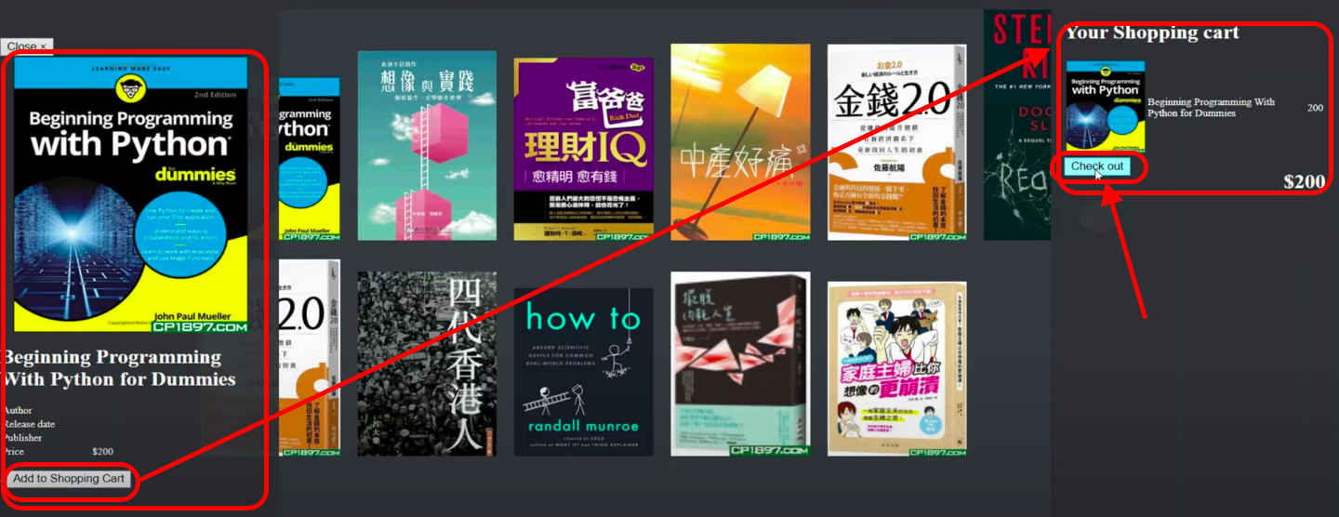

**Error Testing:**

**To test if any error may happen and its showing results after handling.**

**Invalid Input / Empty input:**

The error messages will show up in the bottom of the “Create account” button if the user input nothing or miss something when clicking on the “Create account”.

OUTPUT MESSAGES:

Email / Password / Confirm Password not filled

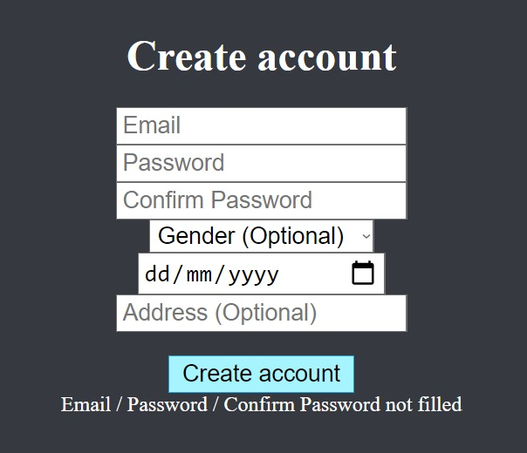

**Wrong password / Invalid email**



If the wrong email or password is inputted and if the email or password does not exist in the database, the system will remind the user.

OUTPUT MESSAGES:

Wrong Email / Password

User & technical documentation:

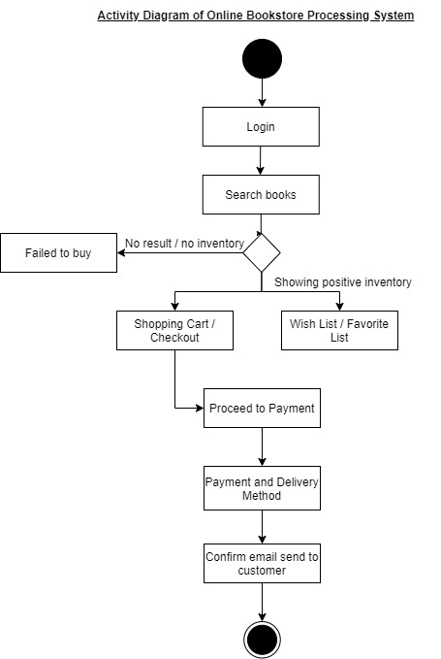

First of all, Visitors must register with the platform before an order can be placed, which would be one of the processes to collect both their personal and payment information. If registered, to ensure easy sign-in to the site, a username and password will be given. When the appropriate books are found by a customer, they may add them to the shopping cart to continue with the purchases. The customer will check the orders he has placed, including the specifics of the item and the total price, and the items should be delivered to the delivery address listed. He/she can search for a product using keywords such as a book title, publisher, and a book ISBN No. or an author name or manufacturer. Alternatively, visitors may wish to simply browse the different categories. For first-hand shopping, an online bookstore processing system.

Secondly, The above Activity diagram shows some main activities when a user is browsing our website. The online bookstore processing system will work as the following: firstly login by input the registered password and user ID, after the system validates it, customers can search the book which they are interested in by using the book ISBN, Name, publisher, or author. It is failing to buy if no results are running out or showing there is no inventory recently. In the other case, customers successfully find their book if there are results printed out, they can proceed to the shopping cart and to do the payment, choosing the delivery method, and receiving a confirmed email. Customers can also save the searching result to the wish list and favorite list first for later purchases and can also be a shopping record.

Last but not least, We will first implement our online bookstore processing system to evaluate and do improvements, after that we will widen our business in different areas. Like we may upgrade courier works from regional to international, customers can shop without the time and place constraints. Moreover, we may expand the user experience through adding more functions like "Wish list" or "favourite list". There will be more updates in plans. We believe that all these ideas will gain more attractions from potential consumers and publishers.

CHAN YIK KIT (AMY) (56237852)

One Page reflection

Overview of our group projects, including 104KM, 118COM, and 122COM. I am really glad to form a group and everyone does have the contribution of our group projects. Both Knowledges shared the technical parts of modules and new relationships built when I worked on those projects. We worked together effectively. We understood each of our strengths and weaknesses, making sure they were used and improved. One very good aspect was the way we created a chat group through our contacts and made sure that we have a platform to discuss the details of our project. We felt relaxed sharing our ideas with members. Keep briefing and progressing.

Back to the first time when we start to have this idea. We think about the recent situation. People are highly worried about the hygienic issue in everyday life during the COVID-19, so more consumers choose to buy online, and reading is often assumed to be a suggested interest in passing this challenging time. There have not been several years of online book markets, there is a lack of consumer contact, and there is also a need to address more practical issues. We wanted to develop an online bookstore processing system to allow changes to the book sales and the efficiency of the customer service. We hope the new processing system for online bookstores would offer us higher market revenue, fresher activities, and greater productivity.

Those projects this year remind me of many things about working in a technology business. I should have more concern for the service provided to customers as it has a lot of differences compared to the traditional businesses. Technology always changes, changes every second. Customers can not be face-to-face and without so many constraints. Technical testing is very necessary when doing a program. All those reports have to keep for references when handling errors. Using the mindset of those program users to build the product. Keep doing evaluation and make sure the quality of user experience. Not just external, also the internal. Staff and/or system administrators can highly use those functions to finish their duties without difficulties. Keep reviewing and move forward when creating or joining a technology business. There are many more I gain from those group projects. Hope our idea is work and influential to society.

To sum up, we finished the creation of the platform but there are still more that we need to fix. IZZBookstore is a good example of branding the change of generation from a brick-and-mortar store to intangible online shopping and payment. Following the steps of technology, change is not easy. Before that, I should keep learning and improving my scripting languages and related useful knowledge of technology business for the future. Team relationship managing and time management should also practice more.

122 one-page reflection

Name: Chen Tak Hei

Student ID: 56226087

At the very first beginning, which was not a long time ago, we four sat around the table in the Starbucks, thinking and brainstorming the ideas of the project really hard, and finally an inspiration came out, which is this online e-commerce book store processing system. We named this bookstore as “IZZ Bookstore” because the name “IZZ” looks quite similar to this module’s code, “122”.

I am responsible for the Python implementation in this project, with the help from Zachary of the HTML interface part. Throughout the whole project, the most challenging part is to do with the database connectivity in Python. At first, I tried to use pyodbc and the result was unsuccessful, I have tried to deal with the problem quite some time, however it cannot be done, and therefore I used pymysql instead. In the python file, it is designed for our staff (admin) to check the records of customer login information, book details, and see a chart of the customer buy the quantity of our products each time, which can help us to investigate how our customers’ preference of buying our products, so we can make further business strategies.

I am fortunate and grateful to work with these people, Amy, Justine, and Zachary. It has been a very interesting experience, I had struggled, and felt dreadful, exhausted, but also satisfied because I learnt how to make the program better and become more interested in doing programming. I had put a lot of time and effort into this project, and so did my groupmates. This application would not make it without their effort.

Name: Lai Justine

SID: 56235545

Through the group projects that we have done this year, I think the communication between group mates has been improved as we can discuss our projects face to face. Although technology nowadays can let us discuss online, face to face do help us to increase our motivation to complete the projects and let us know each other better. After several group meetings, we know each other's personalities and their strengths and weaknesses which are important when we need to work together as a team. It is easier to share our point of view regarding the project when we have more interaction. We brain-storm about the idea of the project and solve the problem immediately. I believe that helps us to get a better result on our projects.

The reason why we want to create an online bookstore is because of the COVID-19. It has been a year and it has not come to an end. Many people prefer to stay at home instead of hanging out with friends. Reading books is a good way to spend our spare time even when we are alone. Therefore, we hope an online bookstore could help to get books they want effectively and efficiently. Also, they do not need to be concerned about the spread of viruses.

In this project, although I did not help much on the program implementation, I do learn much about the program. I may not really understand what code should be used in different parts, but my group mates will explain to me how it works. When there is any question I cannot figure it out, they are helpful and we will solve it together. I am glad that I can do projects with them and hope we can work together in the near future.

**Law Hong Chun Zachary Reflection**

From this group project, we aim to develop an online bookstore website, by using a dataset we have created, the advantage of our online bookstore website would be beneficial for every Hong Kong book lover. Specifically we created a book library browser, a user account creation page, user account login and logout system. But there is always room for improvement.

Firstly, as I participate in group project of the program implementation part which writes the frontend website page for customers. I had done terribly poor on data verification, on user creation page, I did not check for email address format as there would be countless domain name exists. Moreover, birth date could be invalid which user could submit birthday in the future. And the hardest data fields to be verify is the user's delivery address, users may sent in invlid delivery address such as an imaginary street name or district in which we cannot determine the delivery address are true or not, it all depends on users reliability on our system. So in future, I should implement a better data verification system where we are using regex format checking or any other programming library to verify users email address, pair up with an great additional programming library EasyPost with its API system to verify users input delivery address to be accurate or not.

Next, there is another problem I have caused while coding this program implementation. That is I have not inserted enough comments on the program, leading to not creating visibility in the program. As this is a group project, other group members who work on the same program, may not understand the process and functions to understand the code better.

With the mistakes I had made in this group project program implementation part, I should be prepared better and think more from the perspective of our users. I am reflecting these mistakes and will do better next time.

Secondly, I participate in the group project of the Presentations and Demonstration Video part which does the video editing of presenting our project result website and to demonstrate on how the website functions. In the video I create an focused grey circular filter onto particular parts of the website in which is an great editing technique to give video viewers an quick overview of our group project website and maybe I should try out more in the future.

From this group project, I have become wiser and should make up for mistakes then further improve my ability to be implemented in future projects.

**CHK122COM Introduction to Computing**

***Group assignment***

**Requirement**

Business Expansion Project

Following the development of the group project application in 121COM, assume that you are running your own company selling the application. The demand for the application is high and you have decided to expand this business. In order to manage your communication and data during this expansion, you will need to:

Design database tables to record some relevant stakeholder data such as (not limited to): a) Customer details (first names, surnames, address etc.)

b) Website management data - login information (username and password) c) Purchase information

• With the data collected/generated, design relational databases using SQL statements to create tables, keys, etc

• Provide reports from queries used in testing the designed tables

• Connect to and query/extract information from the database

d) With the use of Python, HTML, and/or other scripting languages, present a report based on the data in the database. The developed Python code should implement interactive filtering and sorting of the data (after querying any DB or dataset you are using), to find relevant information.

# Project Management

In order to develop the application required, you will need to plan the process by which your team will execute. Develop a project plan using a tool of your choice. Your team will be required to report weekly to the tutor on progress and performance and document baseline and actual activity.

| **Week** | **Activity** | **Guidance & Deliverable** |
| --- | --- | --- |
| **1** | Prepare to manage your projects | Set up an online tool to support PM activities, content management and communication within the team. |
| **2** | Develop a project plan | Develop a project plan based on your understanding of the requirement. Determine what is the skill set of the team and begin to strategies how you will bridge the gap between current knowledge and required knowledge to complete the project. |
| **3,4,5** | Design research  Collate data | Determine area of focus for the Business expansion project.  Justification for the expansion (Business Case)  Define the deliverables and determine how they can be achieved. Clearly define who the business stakeholders and customers are.  Design database tables to record some relevant stakeholder data.  With the data collected/generated, design relational databases using SQL statements to create tables, keys, etc.  Implement these with the use of Entity Relationship Diagram (ERD) Document findings in a report format. |
| **6,7,8,9,10** | Analysis and implementation | Provide reports from queries used in testing the designed tablesWhat does the data tell you? Start working on an interactive report with the use of any appropriate online interactive reporting tool (such as Jreport, ActiveReports, Tableau, d3js, QlikView, or Open Source Charting & Reporting Tools in Python such as MatPlotLib etc.). |
| **11** | Project demonstration and presentation video | Proof read the report. Ensure you are following the CU Harvard referencing standard  [http://www.coventry.ac.uk/study-at-coventry/student-support/academicsupport/centre-for-academic-writing/support-for-students/academic-writingresources/cu-harvard-reference-style-guide/](http://www.coventry.ac.uk/study-at-coventry/student-support/academic-support/centre-for-academic-writing/support-for-students/academic-writing-resources/cu-harvard-reference-style-guide/) |
| **12** | Individual Viva | You will have allocated slots during the week for your viva. |

**Marking criteria**

| **Activity/Task** | **Assessment weight** |
| --- | --- |
| Problem Specification and Design:  Identify (10 %)   * input requirements in terms of value range, format, restrictions/tolerance to input, using external or internal data, and way to terminate data input. * output requirements in terms of values produced, format, and amount of output. * special relationship between input and output (for example, how the program handles invalid transaction code), and error handling/recovery procedure.   Develop an object model of your system (showing data fields and methods) which should also be modelled by using Python (5 %)  Project management: (5 %)   * languages, tools and platforms adopted * planning, meeting deadlines, coping with events and scheduling conflicts • task and team management | 20% |
| Python Implementation   * you should follow the [Style Guide for Python Code](https://www.python.org/dev/peps/pep-0008/) in writing your program. Internal program documentation is required and should include the program/module header and usage of descriptive names and comments. * develop a Python program for the **Create, Read, Update and Delete (CRUD) activities**, with database integrity control, for the identified database tables in your project. It is expected that pyodbc and MySQL should be used in the Python program you are going to develop. A good user interface of input screen design is also expected * produce the output required. | 40% |
| Program correctness  • test the program with valid case data (10%), boundary case data(5%), special case data and invalid case data (5%) | 20% |
| User and technical documentation  5% • descriptions on commands to invoke the application, details of interactions, explanation of messages produced, and limitations of the application. | 5% |
| One-page reflection and summary of work done and contribution by each team member | 5% (individual mark) |
| Presentations and Demonstration Video | 10% |